RTNS TECH CARD – MUST BRING THIS COMPLETED OVER TO OUR TECH AREA PRIOR TO GOING INTO STAGING AREA!

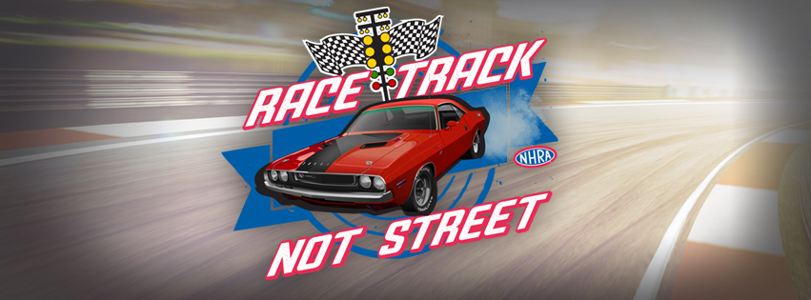
DATE:_________________________

CARD/CAR #:___________________

NAME:___________________________________AGE:_____________

ADDRESS:_________________________________________________

CITY/STATE:_______________________________ZIP:_____________

EMAIL:____________________________________________________

YEAR & MAKE OF CAR:_______________________________________

CUBIC INCHES:______________________________________________

IN CONSIDERATION OF HAVING BEEN PROVIDED TECHNICAL INSPECTION AND FOR BEING ALLOWED TO COMPETE IN THE EVENT, I AFFIRM THAT I HAVE READ AND UNDERSTAND ALL NHRA RULES AND REGULATIONS, INCLUDING THOSE FOUND IN THE NHRA RULEBOOK, WITH SPECIFIC REFERENCE BUT NOT LIMITED TO THE RULES, REGULATIONS AND AGREEMENTS CONTAINED IN THE ADMINISTRATION PROCEDURES AND APPEALS SECTION WHICH ARE INCORPORATED HEREIN BY THIS REFERENCE AND I AGREE TO BE BOUND BY ALL SUCH RULES, REGULATIONS AND AGREEMENTS.

DRIVER’S SIGNATURE:_______________________________________________

PLEASE PRINT CLEARLY IN INK!
ALL CARS MUST HAVE MUFFLERS

